**Aligning RGB images and correcting for the X, Y offsets using ImageJ**

**Protocol AL_10**

1. Open images that will be merged in ImageJ (Fiji).

*Note:* In order to merge channels using this protocol, all images must have the same dimensions.

1. Adjust brightness/contrast for each image.
2. Go to *Image>Color>Merge channels*
3. Using the drop-down menu assign images to appropriate channels (as shown below). Select ‘*Create composite*’*.* By using composite image you can still adjust parameters of each channel (for instance, brightness and contrast) of the merged image.

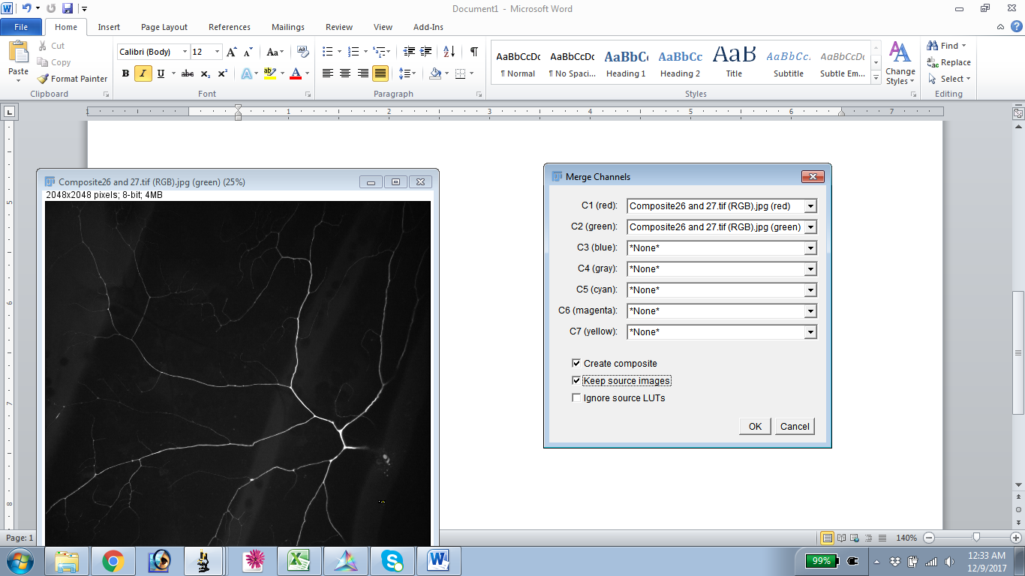

1. Inspect whether channels overlap well with each other. In case of x,y offset between channels use plugin ‘Template matching’ for correction.

*Note*: This plugin is not built into FIJI and has to be downloaded separately.

1. Go to *Plugins> Templet matching> Align slices in stack*.
2. From the drop down menu selected matching method and mark ‘Subpixel registration’, hit ‘OK’.

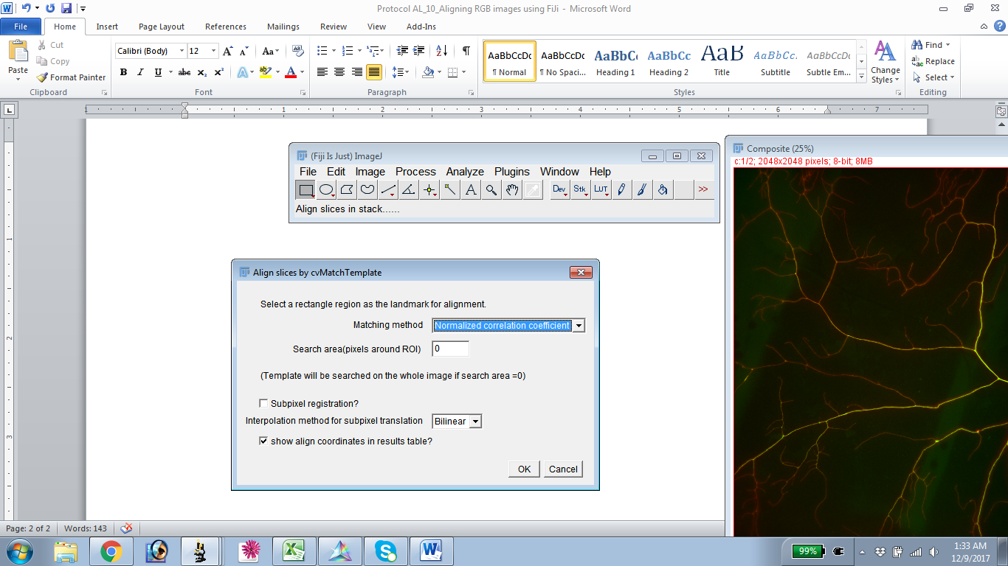

1. Now you will be ask to select a landmark in your composite image that will be used as a reference point to align channels. The landmark has to be unique otherwise the alignment will not work. Press ‘OK’ for the plugin to run the algorithm.

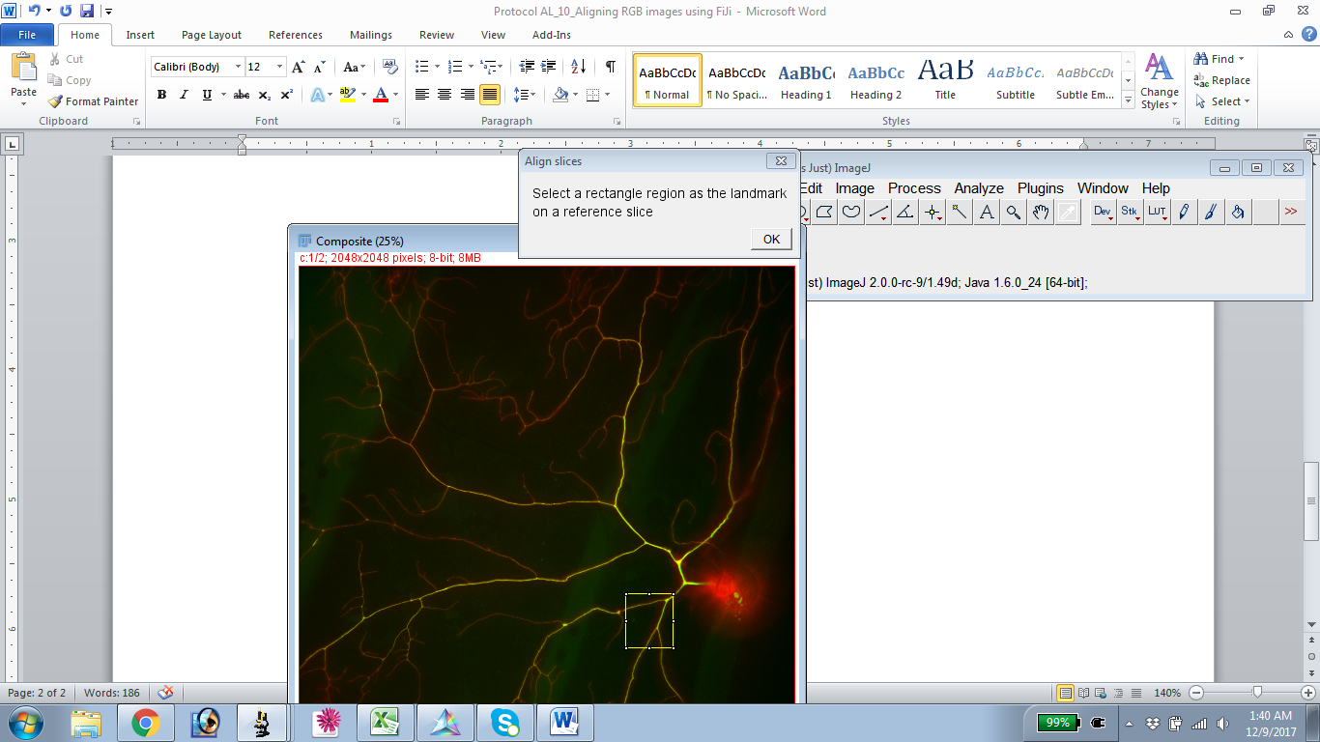

*Note*: Plugin will perform operation and apply changes to the open image, thus it is a good practice to **duplicate** the composite before starting the alignment.